**Laporan Praktikum**

**Bahasa Pemrograman 1**

**Dosen pengampu : (*Dede Husen, M.Kom.*)**

# Modul 3



**Nama : Muhammad Rizal Nurfirdaus**

**NIM : 20230810088**

**Kelas : TINFC – 2023 – 04**

**Teknik Informatika Fakultas Ilmu Komputer**

**Universitas Kuningan**

# Pre Test

1. Apa itu Swing?

Swing adalah bagian dari Java Foundation Classes (JFC) yang menyediakan pustaka untuk membangun antarmuka grafis pengguna (GUI) di Java. Berbeda dengan AWT, yang bergantung pada komponen sistem operasi, Swing bersifat *lightweight*, sehingga tampilannya konsisten di berbagai platform. Swing memungkinkan pengembang membuat elemen GUI seperti tombol, kotak teks, menu, dan jendela dialog yang dapat disesuaikan dan memiliki banyak fitur.

1. Apa fungsi dari Swing?

Fungsi utama Swing adalah menyediakan alat untuk membangun antarmuka grafis interaktif di Java. Dengan menggunakan Swing, pengembang dapat membuat aplikasi desktop dengan komponen visual seperti tombol, tabel, daftar, panel, dan banyak lagi. Swing juga mendukung pemrograman event-driven (berbasis peristiwa) sehingga aplikasi dapat merespons tindakan pengguna, seperti klik, input teks, dan navigasi menu.

1. Tuliskan contoh program sederhana untuk Swing container dan menu!

import javax.swing.*;

public class AplikasiSwingSederhana extends JFrame {

public AplikasiSwingSederhana() {

// Atur judul jendela

setTitle("Contoh Swing dengan Menu");

// Atur ukuran dan operasi tutup default

setSize(400, 300);

setDefaultCloseOperation(JFrame.EXIT_ON_CLOSE);

// Membuat menu bar

JMenuBar menuBar = new JMenuBar();

// Membuat menu

JMenu menuFile = new JMenu("File");

JMenu menuEdit = new JMenu("Edit");

// Membuat item menu

JMenuItem itemBuka = new JMenuItem("Buka");

JMenuItem itemSimpan = new JMenuItem("Simpan");

JMenuItem itemKeluar = new JMenuItem("Keluar");

// Menambahkan item ke dalam menu File

menuFile.add(itemBuka);

menuFile.add(itemSimpan);

menuFile.addSeparator(); // Menambahkan garis pemisah

menuFile.add(itemKeluar);

// Menambahkan menu ke menu bar

menuBar.add(menuFile);

menuBar.add(menuEdit);

// Mengatur menu bar ke dalam frame

setJMenuBar(menuBar);

// Tambahkan aksi untuk item menu Keluar

itemKeluar.addActionListener(e -> System.exit(0));

// Menambahkan container sederhana (JPanel) dengan label

JPanel panel = new JPanel();

JLabel label = new JLabel("Selamat datang di Aplikasi Swing Sederhana!");

panel.add(label);

// Menambahkan panel ke dalam frame

add(panel);

// Menampilkan jendela

setVisible(true);

}

public static void main(String[] args) {

// Jalankan aplikasi

new AplikasiSwingSederhana();

}

}

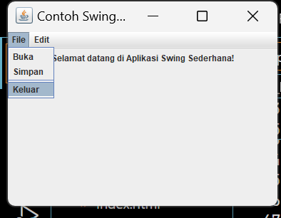

**Praktikum**

1. **BP1_M3_P1_Rizal_Container**

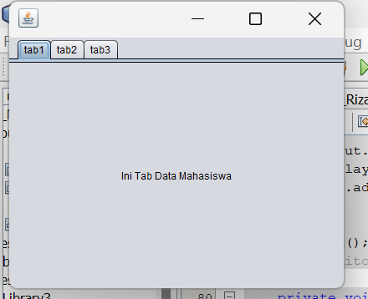

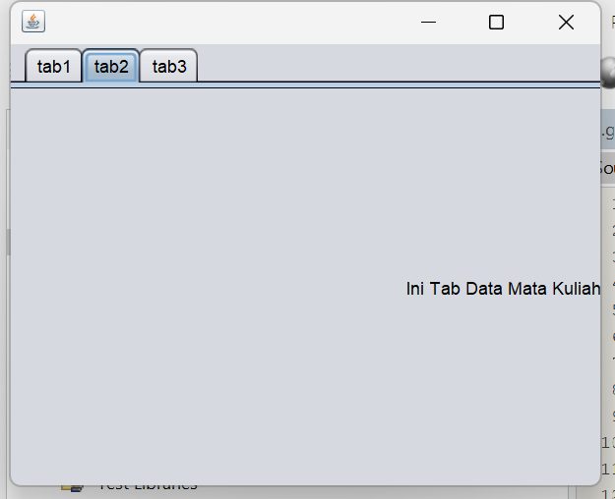

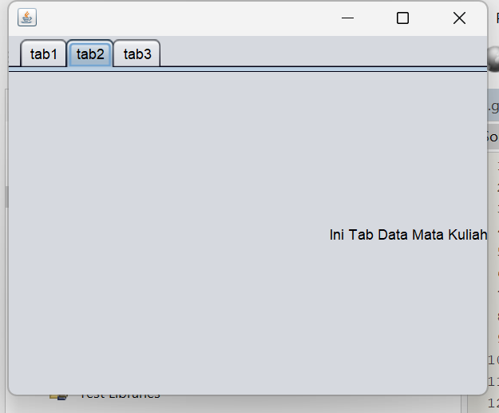

**Script Code :** /*

import javax.swing.JOptionPane;

/*

* To change this license header, choose License Headers in Project Properties.

* To change this template file, choose Tools | Templates

* and open the template in the editor.

*/

/**

*

* @author Muhammad Rizal Nur F

*/

public class BP1_M3_P1_Rizal_Container extends javax.swing.JFrame {

/**

* Creates new form BP1_M3_P1_Rizal_Container

*/

public BP1_M3_P1_Rizal_Container() {

initComponents();

}

/**

* This method is called from within the constructor to initialize the form.

* WARNING: Do NOT modify this code. The content of this method is always

* regenerated by the Form Editor.

*/

@SuppressWarnings("unchecked")

// <editor-fold defaultstate="collapsed" desc="Generated Code">

private void initComponents() {

jTabbedPane1 = new javax.swing.JTabbedPane();

jLabel1 = new javax.swing.JLabel();

jLabel2 = new javax.swing.JLabel();

jLabel3 = new javax.swing.JLabel();

setDefaultCloseOperation(javax.swing.WindowConstants.EXIT_ON_CLOSE);

jLabel1.setHorizontalAlignment(javax.swing.SwingConstants.CENTER);

jLabel1.setText("Ini Tab Data Mahasiswa");

jLabel1.addMouseListener(new java.awt.event.MouseAdapter() {

public void mouseClicked(java.awt.event.MouseEvent evt) {

jLabel1MouseClicked(evt);

}

});

jTabbedPane1.addTab("tab1", jLabel1);

jLabel2.setHorizontalAlignment(javax.swing.SwingConstants.RIGHT);

jLabel2.setText("Ini Tab Data Mata Kuliah");

jLabel2.addMouseListener(new java.awt.event.MouseAdapter() {

public void mouseClicked(java.awt.event.MouseEvent evt) {

jLabel2MouseClicked(evt);

}

});

jTabbedPane1.addTab("tab2", jLabel2);

jLabel3.setHorizontalAlignment(javax.swing.SwingConstants.LEFT);

jLabel3.setText("Ini Tab Data Nilai");

jLabel3.addMouseListener(new java.awt.event.MouseAdapter() {

public void mouseClicked(java.awt.event.MouseEvent evt) {

jLabel3MouseClicked(evt);

}

});

jTabbedPane1.addTab("tab3", jLabel3);

javax.swing.GroupLayout layout = new javax.swing.GroupLayout(getContentPane());

getContentPane().setLayout(layout);

layout.setHorizontalGroup(

layout.createParallelGroup(javax.swing.GroupLayout.Alignment.LEADING)

.addComponent(jTabbedPane1, javax.swing.GroupLayout.DEFAULT_SIZE, 400, Short.MAX_VALUE)

);

layout.setVerticalGroup(

layout.createParallelGroup(javax.swing.GroupLayout.Alignment.LEADING)

.addComponent(jTabbedPane1, javax.swing.GroupLayout.DEFAULT_SIZE, 300, Short.MAX_VALUE)

);

pack();

}// </editor-fold>

private void jLabel1MouseClicked(java.awt.event.MouseEvent evt) {

// TODO add your handling code here:

JOptionPane.showMessageDialog(null,"Ini tab Data Mahasiswa", "Informasi", JOptionPane .INFORMATION_MESSAGE);

}

private void jLabel2MouseClicked(java.awt.event.MouseEvent evt) {

// TODO add your handling code here:

int close = JOptionPane.showOptionDialog(this, "Ini tab Data Mata Kuliah! Keluar Aplikasi","YesNoOption", JOptionPane.YES_NO_OPTION, JOptionPane.QUESTION_MESSAGE, null, null, null);

if(close == JOptionPane.YES_OPTION){

this.dispose();

}

}

private void jLabel3MouseClicked(java.awt.event.MouseEvent evt) {

// TODO add your handling code here:

JOptionPane.showMessageDialog(null,"Ini tab Data Mahasiswa", "Informasi", JOptionPane .ERROR_MESSAGE);

}

/**

* @param args the command line arguments

*/

public static void main(String args[]) {

/* Set the Nimbus look and feel */

//<editor-fold defaultstate="collapsed" desc=" Look and feel setting code (optional) ">

/* If Nimbus (introduced in Java SE 6) is not available, stay with the default look and feel.

* For details see http://download.oracle.com/javase/tutorial/uiswing/lookandfeel/plaf.html

*/

try {

for (javax.swing.UIManager.LookAndFeelInfo info : javax.swing.UIManager.getInstalledLookAndFeels()) {

if ("Nimbus".equals(info.getName())) {

javax.swing.UIManager.setLookAndFeel(info.getClassName());

break;

}

}

} catch (ClassNotFoundException ex) {

java.util.logging.Logger.getLogger(BP1_M3_P1_Rizal_Container.class.getName()).log(java.util.logging.Level.SEVERE, null, ex);

} catch (InstantiationException ex) {

java.util.logging.Logger.getLogger(BP1_M3_P1_Rizal_Container.class.getName()).log(java.util.logging.Level.SEVERE, null, ex);

} catch (IllegalAccessException ex) {

java.util.logging.Logger.getLogger(BP1_M3_P1_Rizal_Container.class.getName()).log(java.util.logging.Level.SEVERE, null, ex);

} catch (javax.swing.UnsupportedLookAndFeelException ex) {

java.util.logging.Logger.getLogger(BP1_M3_P1_Rizal_Container.class.getName()).log(java.util.logging.Level.SEVERE, null, ex);

}

//</editor-fold>

/* Create and display the form */

java.awt.EventQueue.invokeLater(new Runnable() {

public void run() {

new BP1_M3_P1_Rizal_Container().setVisible(true);

}

});

}

// Variables declaration - do not modify

private javax.swing.JLabel jLabel1;

private javax.swing.JLabel jLabel2;

private javax.swing.JLabel jLabel3;

private javax.swing.JTabbedPane jTabbedPane1;

// End of variables declaration

}

**Analisis :**

Program Java ini adalah aplikasi GUI berbasis Swing yang membuat jendela dengan tiga tab menggunakan `JTabbedPane`. Setiap tab berisi label teks berbeda, yaitu "Data Mahasiswa," "Data Mata Kuliah," dan "Data Nilai." Ketika label diklik:

- Tab "Data Mahasiswa" menampilkan pesan informasi.

- Tab "Data Mata Kuliah" menampilkan opsi dialog untuk keluar dari aplikasi.

- Tab "Data Nilai" menampilkan pesan error.

Program ini menggunakan `JOptionPane` untuk menampilkan pesan di setiap tab.

1. BP1_M3_P2_Rizal  
   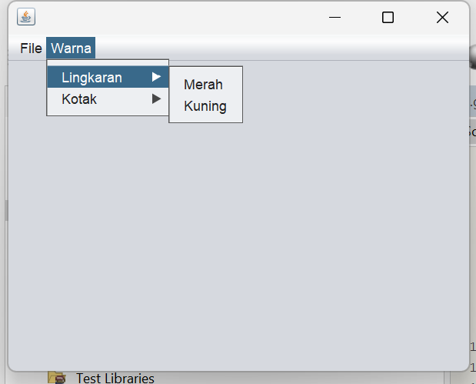

Script Code :  
/*

* To change this license header, choose License Headers in Project Properties.

* To change this template file, choose Tools | Templates

* and open the template in the editor.

*/

/**

*

* @author Muhammad Rizal Nur F

*/

public class BP1_M3_P2_Rizal extends javax.swing.JFrame {

/**

* Creates new form BP1_M3_P2_Rizal

*/

public BP1_M3_P2_Rizal() {

initComponents();

}

/**

* This method is called from within the constructor to initialize the form.

* WARNING: Do NOT modify this code. The content of this method is always

* regenerated by the Form Editor.

*/

@SuppressWarnings("unchecked")

// <editor-fold defaultstate="collapsed" desc="Generated Code">

private void initComponents() {

jMenuBar1 = new javax.swing.JMenuBar();

jMenu1 = new javax.swing.JMenu();

jMenuItem1 = new javax.swing.JMenuItem();

jMenuItem2 = new javax.swing.JMenuItem();

jMenu2 = new javax.swing.JMenu();

jMenu4 = new javax.swing.JMenu();

jMenuItem3 = new javax.swing.JMenuItem();

jMenuItem6 = new javax.swing.JMenuItem();

jMenu5 = new javax.swing.JMenu();

jMenuItem4 = new javax.swing.JMenuItem();

jMenuItem5 = new javax.swing.JMenuItem();

setDefaultCloseOperation(javax.swing.WindowConstants.EXIT_ON_CLOSE);

jMenu1.setText("File");

jMenuItem1.setText("Buka");

jMenu1.add(jMenuItem1);

jMenuItem2.setText("Simpan");

jMenu1.add(jMenuItem2);

jMenuBar1.add(jMenu1);

jMenu2.setText("Warna");

jMenu4.setText("Lingkaran");

jMenuItem3.setText("Merah");

jMenuItem3.addActionListener(new java.awt.event.ActionListener() {

public void actionPerformed(java.awt.event.ActionEvent evt) {

jMenuItem3ActionPerformed(evt);

}

});

jMenu4.add(jMenuItem3);

jMenuItem6.setText("Kuning");

jMenuItem6.addActionListener(new java.awt.event.ActionListener() {

public void actionPerformed(java.awt.event.ActionEvent evt) {

jMenuItem6ActionPerformed(evt);

}

});

jMenu4.add(jMenuItem6);

jMenu2.add(jMenu4);

jMenu5.setText("Kotak");

jMenuItem4.setText("Merah");

jMenu5.add(jMenuItem4);

jMenuItem5.setText("Biru");

jMenuItem5.addActionListener(new java.awt.event.ActionListener() {

public void actionPerformed(java.awt.event.ActionEvent evt) {

jMenuItem5ActionPerformed(evt);

}

});

jMenu5.add(jMenuItem5);

jMenu2.add(jMenu5);

jMenuBar1.add(jMenu2);

setJMenuBar(jMenuBar1);

javax.swing.GroupLayout layout = new javax.swing.GroupLayout(getContentPane());

getContentPane().setLayout(layout);

layout.setHorizontalGroup(

layout.createParallelGroup(javax.swing.GroupLayout.Alignment.LEADING)

.addGap(0, 400, Short.MAX_VALUE)

);

layout.setVerticalGroup(

layout.createParallelGroup(javax.swing.GroupLayout.Alignment.LEADING)

.addGap(0, 269, Short.MAX_VALUE)

);

pack();

}// </editor-fold>

private void jMenuItem3ActionPerformed(java.awt.event.ActionEvent evt) {

// TODO add your handling code here:

}

private void jMenuItem6ActionPerformed(java.awt.event.ActionEvent evt) {

// TODO add your handling code here:

}

private void jMenuItem5ActionPerformed(java.awt.event.ActionEvent evt) {

// TODO add your handling code here:

}

/**

* @param args the command line arguments

*/

public static void main(String args[]) {

/* Set the Nimbus look and feel */

//<editor-fold defaultstate="collapsed" desc=" Look and feel setting code (optional) ">

/* If Nimbus (introduced in Java SE 6) is not available, stay with the default look and feel.

* For details see http://download.oracle.com/javase/tutorial/uiswing/lookandfeel/plaf.html

*/

try {

for (javax.swing.UIManager.LookAndFeelInfo info : javax.swing.UIManager.getInstalledLookAndFeels()) {

if ("Nimbus".equals(info.getName())) {

javax.swing.UIManager.setLookAndFeel(info.getClassName());

break;

}

}

} catch (ClassNotFoundException ex) {

java.util.logging.Logger.getLogger(BP1_M3_P2_Rizal.class.getName()).log(java.util.logging.Level.SEVERE, null, ex);

} catch (InstantiationException ex) {

java.util.logging.Logger.getLogger(BP1_M3_P2_Rizal.class.getName()).log(java.util.logging.Level.SEVERE, null, ex);

} catch (IllegalAccessException ex) {

java.util.logging.Logger.getLogger(BP1_M3_P2_Rizal.class.getName()).log(java.util.logging.Level.SEVERE, null, ex);

} catch (javax.swing.UnsupportedLookAndFeelException ex) {

java.util.logging.Logger.getLogger(BP1_M3_P2_Rizal.class.getName()).log(java.util.logging.Level.SEVERE, null, ex);

}

//</editor-fold>

/* Create and display the form */

java.awt.EventQueue.invokeLater(new Runnable() {

public void run() {

new BP1_M3_P2_Rizal().setVisible(true);

}

});

}

// Variables declaration - do not modify

private javax.swing.JMenu jMenu1;

private javax.swing.JMenu jMenu2;

private javax.swing.JMenu jMenu4;

private javax.swing.JMenu jMenu5;

private javax.swing.JMenuBar jMenuBar1;

private javax.swing.JMenuItem jMenuItem1;

private javax.swing.JMenuItem jMenuItem2;

private javax.swing.JMenuItem jMenuItem3;

private javax.swing.JMenuItem jMenuItem4;

private javax.swing.JMenuItem jMenuItem5;

private javax.swing.JMenuItem jMenuItem6;

// End of variables declaration

}

Analisis :

1. **Kelas Utama BP1_M3_P2_Rizal**:

* Ini adalah kelas GUI berbasis JFrame yang membentuk jendela aplikasi menggunakan Java Swing.
* Konstruktornya menginisialisasi komponen dengan memanggil initComponents() untuk mengatur elemen antarmuka.

1. **Menu Bar dan Menu**:

* Program membuat menu bar (JMenuBar) dengan dua menu utama: File dan Warna.
* Menu File berisi item Buka dan Simpan.
* Menu Warna berisi dua submenu: Lingkaran (dengan item Merah dan Kuning) dan Kotak (dengan item Merah dan Biru).

1. **Aksi Item Menu**:

* Setiap item menu memiliki listener (ActionListener), tetapi saat ini belum ada aksi spesifik yang dilakukan ketika item diklik. Hanya berupa placeholder // TODO add your handling code here:.

1. **Metode main**:

* Metode ini menjalankan aplikasi dengan mengatur tampilan Nimbus (jika tersedia) dan menampilkan jendela utama.

**Post Test**

1. **BP1_M3_PostTest1_Rizal_**

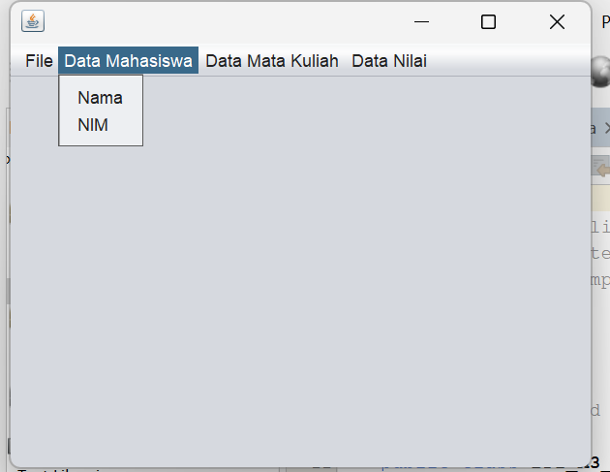

**Script Code :**

/*

* To change this license header, choose License Headers in Project Properties.

* To change this template file, choose Tools | Templates

* and open the template in the editor.

*/

/**

*

* @author Muhammad Rizal Nur F

*/

public class BP1_M3_PostTest1_Rizal extends javax.swing.JFrame {

/**

* Creates new form BP1_M3_PostTest1_Rizal

*/

public BP1_M3_PostTest1_Rizal() {

initComponents();

}

/**

* This method is called from within the constructor to initialize the form.

* WARNING: Do NOT modify this code. The content of this method is always

* regenerated by the Form Editor.

*/

@SuppressWarnings("unchecked")

// <editor-fold defaultstate="collapsed" desc="Generated Code">

private void initComponents() {

jMenuBar1 = new javax.swing.JMenuBar();

jMenu1 = new javax.swing.JMenu();

jMenuItem1 = new javax.swing.JMenuItem();

jMenuItem2 = new javax.swing.JMenuItem();

jMenu2 = new javax.swing.JMenu();

jMenuItem3 = new javax.swing.JMenuItem();

jMenuItem4 = new javax.swing.JMenuItem();

jMenu3 = new javax.swing.JMenu();

jMenuItem5 = new javax.swing.JMenuItem();

jMenuItem6 = new javax.swing.JMenuItem();

jMenu4 = new javax.swing.JMenu();

jMenuItem7 = new javax.swing.JMenuItem();

jMenuItem8 = new javax.swing.JMenuItem();

setDefaultCloseOperation(javax.swing.WindowConstants.EXIT_ON_CLOSE);

jMenu1.setText("File");

jMenu1.addMouseListener(new java.awt.event.MouseAdapter() {

public void mouseClicked(java.awt.event.MouseEvent evt) {

jMenu1MouseClicked(evt);

}

});

jMenuItem1.setText("Buka");

jMenuItem1.addMouseListener(new java.awt.event.MouseAdapter() {

public void mouseClicked(java.awt.event.MouseEvent evt) {

jMenuItem1MouseClicked(evt);

}

});

jMenu1.add(jMenuItem1);

jMenuItem2.setText("Simpan");

jMenuItem2.addMouseListener(new java.awt.event.MouseAdapter() {

public void mouseClicked(java.awt.event.MouseEvent evt) {

jMenuItem2MouseClicked(evt);

}

});

jMenu1.add(jMenuItem2);

jMenuBar1.add(jMenu1);

jMenu2.setText("Data Mahasiswa");

jMenu2.addMouseListener(new java.awt.event.MouseAdapter() {

public void mouseClicked(java.awt.event.MouseEvent evt) {

jMenu2MouseClicked(evt);

}

});

jMenuItem3.setText("Nama");

jMenuItem3.addMouseListener(new java.awt.event.MouseAdapter() {

public void mouseClicked(java.awt.event.MouseEvent evt) {

jMenuItem3MouseClicked(evt);

}

});

jMenu2.add(jMenuItem3);

jMenuItem4.setText("NIM");

jMenuItem4.addMouseListener(new java.awt.event.MouseAdapter() {

public void mouseClicked(java.awt.event.MouseEvent evt) {

jMenuItem4MouseClicked(evt);

}

});

jMenu2.add(jMenuItem4);

jMenuBar1.add(jMenu2);

jMenu3.setText("Data Mata Kuliah");

jMenu3.addMouseListener(new java.awt.event.MouseAdapter() {

public void mouseClicked(java.awt.event.MouseEvent evt) {

jMenu3MouseClicked(evt);

}

});

jMenuItem5.setText("Materi");

jMenuItem5.addMouseListener(new java.awt.event.MouseAdapter() {

public void mouseClicked(java.awt.event.MouseEvent evt) {

jMenuItem5MouseClicked(evt);

}

});

jMenu3.add(jMenuItem5);

jMenuItem6.setText("Praktikum");

jMenuItem6.addMouseListener(new java.awt.event.MouseAdapter() {

public void mouseClicked(java.awt.event.MouseEvent evt) {

jMenuItem6MouseClicked(evt);

}

});

jMenuItem6.addActionListener(new java.awt.event.ActionListener() {

public void actionPerformed(java.awt.event.ActionEvent evt) {

jMenuItem6ActionPerformed(evt);

}

});

jMenu3.add(jMenuItem6);

jMenuBar1.add(jMenu3);

jMenu4.setText("Data Nilai");

jMenu4.addMouseListener(new java.awt.event.MouseAdapter() {

public void mouseClicked(java.awt.event.MouseEvent evt) {

jMenu4MouseClicked(evt);

}

});

jMenuItem7.setText("Nilai UTS");

jMenuItem7.addMouseListener(new java.awt.event.MouseAdapter() {

public void mouseClicked(java.awt.event.MouseEvent evt) {

jMenuItem7MouseClicked(evt);

}

});

jMenu4.add(jMenuItem7);

jMenuItem8.setText("Nilai UAS");

jMenuItem8.addMouseListener(new java.awt.event.MouseAdapter() {

public void mouseClicked(java.awt.event.MouseEvent evt) {

jMenuItem8MouseClicked(evt);

}

});

jMenu4.add(jMenuItem8);

jMenuBar1.add(jMenu4);

setJMenuBar(jMenuBar1);

javax.swing.GroupLayout layout = new javax.swing.GroupLayout(getContentPane());

getContentPane().setLayout(layout);

layout.setHorizontalGroup(

layout.createParallelGroup(javax.swing.GroupLayout.Alignment.LEADING)

.addGap(0, 400, Short.MAX_VALUE)

);

layout.setVerticalGroup(

layout.createParallelGroup(javax.swing.GroupLayout.Alignment.LEADING)

.addGap(0, 269, Short.MAX_VALUE)

);

pack();

}// </editor-fold>

private void jMenuItem6ActionPerformed(java.awt.event.ActionEvent evt) {

// TODO add your handling code here:

}

private void jMenu1MouseClicked(java.awt.event.MouseEvent evt) {

// TODO add your handling code here:

}

private void jMenuItem1MouseClicked(java.awt.event.MouseEvent evt) {

// TODO add your handling code here:

}

private void jMenuItem2MouseClicked(java.awt.event.MouseEvent evt) {

// TODO add your handling code here:

}

private void jMenu2MouseClicked(java.awt.event.MouseEvent evt) {

// TODO add your handling code here:

}

private void jMenuItem3MouseClicked(java.awt.event.MouseEvent evt) {

// TODO add your handling code here:

}

private void jMenuItem4MouseClicked(java.awt.event.MouseEvent evt) {

// TODO add your handling code here:

}

private void jMenu3MouseClicked(java.awt.event.MouseEvent evt) {

// TODO add your handling code here:

}

private void jMenuItem5MouseClicked(java.awt.event.MouseEvent evt) {

// TODO add your handling code here:

}

private void jMenuItem6MouseClicked(java.awt.event.MouseEvent evt) {

// TODO add your handling code here:

}

private void jMenu4MouseClicked(java.awt.event.MouseEvent evt) {

// TODO add your handling code here:

}

private void jMenuItem7MouseClicked(java.awt.event.MouseEvent evt) {

// TODO add your handling code here:

}

private void jMenuItem8MouseClicked(java.awt.event.MouseEvent evt) {

// TODO add your handling code here:

}

/**

* @param args the command line arguments

*/

public static void main(String args[]) {

/* Set the Nimbus look and feel */

//<editor-fold defaultstate="collapsed" desc=" Look and feel setting code (optional) ">

/* If Nimbus (introduced in Java SE 6) is not available, stay with the default look and feel.

* For details see http://download.oracle.com/javase/tutorial/uiswing/lookandfeel/plaf.html

*/

try {

for (javax.swing.UIManager.LookAndFeelInfo info : javax.swing.UIManager.getInstalledLookAndFeels()) {

if ("Nimbus".equals(info.getName())) {

javax.swing.UIManager.setLookAndFeel(info.getClassName());

break;

}

}

} catch (ClassNotFoundException ex) {

java.util.logging.Logger.getLogger(BP1_M3_PostTest1_Rizal.class.getName()).log(java.util.logging.Level.SEVERE, null, ex);

} catch (InstantiationException ex) {

java.util.logging.Logger.getLogger(BP1_M3_PostTest1_Rizal.class.getName()).log(java.util.logging.Level.SEVERE, null, ex);

} catch (IllegalAccessException ex) {

java.util.logging.Logger.getLogger(BP1_M3_PostTest1_Rizal.class.getName()).log(java.util.logging.Level.SEVERE, null, ex);

} catch (javax.swing.UnsupportedLookAndFeelException ex) {

java.util.logging.Logger.getLogger(BP1_M3_PostTest1_Rizal.class.getName()).log(java.util.logging.Level.SEVERE, null, ex);

}

//</editor-fold>

/* Create and display the form */

java.awt.EventQueue.invokeLater(new Runnable() {

public void run() {

new BP1_M3_PostTest1_Rizal().setVisible(true);

}

});

}

// Variables declaration - do not modify

private javax.swing.JMenu jMenu1;

private javax.swing.JMenu jMenu2;

private javax.swing.JMenu jMenu3;

private javax.swing.JMenu jMenu4;

private javax.swing.JMenuBar jMenuBar1;

private javax.swing.JMenuItem jMenuItem1;

private javax.swing.JMenuItem jMenuItem2;

private javax.swing.JMenuItem jMenuItem3;

private javax.swing.JMenuItem jMenuItem4;

private javax.swing.JMenuItem jMenuItem5;

private javax.swing.JMenuItem jMenuItem6;

private javax.swing.JMenuItem jMenuItem7;

private javax.swing.JMenuItem jMenuItem8;

// End of variables declaration

}

Analisis :

1. **Kelas BP1_M3_PostTest1_Rizal**: Merupakan kelas GUI berbasis JFrame dengan Java Swing untuk membuat jendela aplikasi.
2. **Menu Bar dan Menu**:

* jMenuBar1 adalah menu bar utama yang berisi 4 menu:
  + **File**: berisi item menu Buka dan Simpan.
  + **Data Mahasiswa**: berisi item Nama dan NIM.
  + **Data Mata Kuliah**: berisi item Materi dan Praktikum.
  + **Data Nilai**: berisi item Nilai UTS dan Nilai UAS.

1. **Event Listener**:

* Setiap item menu memiliki MouseListener yang saat ini hanya berupa placeholder // TODO add your handling code here: tanpa aksi spesifik.

1. **Metode main**:

* Menjalankan tampilan Nimbus (jika tersedia) dan membuka jendela utama aplikasi.

**Tugas**

* 1. **BP1_M3_PostTest1_Rizal**

import javax.swing.*;

import java.io.File;

public class BP1_M3_PostTest1_Rizal extends javax.swing.JFrame {

    public BP1_M3_PostTest1_Rizal() {

        initComponents();

    }

    @SuppressWarnings("unchecked")

    private void initComponents() {

        jMenuBar1 = new javax.swing.JMenuBar();

        jMenu1 = new javax.swing.JMenu();

        jMenuItem1 = new javax.swing.JMenuItem();

        jMenuItem2 = new javax.swing.JMenuItem();

        jMenu2 = new javax.swing.JMenu();

        jMenuItem3 = new javax.swing.JMenuItem();

        jMenuItem4 = new javax.swing.JMenuItem();

        jMenu3 = new javax.swing.JMenu();

        jMenuItem5 = new javax.swing.JMenuItem();

        jMenuItem6 = new javax.swing.JMenuItem();

        jMenu4 = new javax.swing.JMenu();

        jMenuItem7 = new javax.swing.JMenuItem();

        jMenuItem8 = new javax.swing.JMenuItem();

        setDefaultCloseOperation(javax.swing.WindowConstants.EXIT_ON_CLOSE);

        jMenu1.setText("File");

        jMenuItem1.setText("Buka");

        jMenuItem1.addActionListener(new java.awt.event.ActionListener() {

            public void actionPerformed(java.awt.event.ActionEvent evt) {

                jMenuItem1ActionPerformed(evt);

            }

        });

        jMenu1.add(jMenuItem1);

        jMenuItem2.setText("Simpan");

        jMenuItem2.addActionListener(new java.awt.event.ActionListener() {

            public void actionPerformed(java.awt.event.ActionEvent evt) {

                jMenuItem2ActionPerformed(evt);

            }

        });

        jMenu1.add(jMenuItem2);

        jMenuBar1.add(jMenu1);

        jMenu2.setText("Data Mahasiswa");

        jMenuItem3.setText("Nama");

        jMenuItem3.addActionListener(new java.awt.event.ActionListener() {

            public void actionPerformed(java.awt.event.ActionEvent evt) {

                jMenuItem3ActionPerformed(evt);

            }

        });

        jMenu2.add(jMenuItem3);

        jMenuItem4.setText("NIM");

        jMenuItem4.addActionListener(new java.awt.event.ActionListener() {

            public void actionPerformed(java.awt.event.ActionEvent evt) {

                jMenuItem4ActionPerformed(evt);

            }

        });

        jMenu2.add(jMenuItem4);

        jMenuBar1.add(jMenu2);

        jMenu3.setText("Data Mata Kuliah");

        jMenuItem5.setText("Materi");

        jMenuItem5.addActionListener(new java.awt.event.ActionListener() {

            public void actionPerformed(java.awt.event.ActionEvent evt) {

                jMenuItem5ActionPerformed(evt);

            }

        });

        jMenu3.add(jMenuItem5);

        jMenuItem6.setText("Praktikum");

        jMenuItem6.addActionListener(new java.awt.event.ActionListener() {

            public void actionPerformed(java.awt.event.ActionEvent evt) {

                jMenuItem6ActionPerformed(evt);

            }

        });

        jMenu3.add(jMenuItem6);

        jMenuBar1.add(jMenu3);

        jMenu4.setText("Data Nilai");

        jMenuItem7.setText("Nilai UTS");

        jMenuItem7.addActionListener(new java.awt.event.ActionListener() {

            public void actionPerformed(java.awt.event.ActionEvent evt) {

                jMenuItem7ActionPerformed(evt);

            }

        });

        jMenu4.add(jMenuItem7);

        jMenuItem8.setText("Nilai UAS");

        jMenuItem8.addActionListener(new java.awt.event.ActionListener() {

            public void actionPerformed(java.awt.event.ActionEvent evt) {

                jMenuItem8ActionPerformed(evt);

            }

        });

        jMenu4.add(jMenuItem8);

        jMenuBar1.add(jMenu4);

        setJMenuBar(jMenuBar1);

        javax.swing.GroupLayout layout = new javax.swing.GroupLayout(getContentPane());

        getContentPane().setLayout(layout);

        layout.setHorizontalGroup(

            layout.createParallelGroup(javax.swing.GroupLayout.Alignment.LEADING)

            .addGap(0, 400, Short.MAX_VALUE)

        );

        layout.setVerticalGroup(

            layout.createParallelGroup(javax.swing.GroupLayout.Alignment.LEADING)

            .addGap(0, 269, Short.MAX_VALUE)

        );

        pack();

    }

    // ActionListener untuk setiap item menu

    private void jMenuItem1ActionPerformed(java.awt.event.ActionEvent evt) {

        JFileChooser fileChooser = new JFileChooser();

        int returnValue = fileChooser.showOpenDialog(this);

        if (returnValue == JFileChooser.APPROVE_OPTION) {

            File selectedFile = fileChooser.getSelectedFile();

            JOptionPane.showMessageDialog(this, "Buka file: " + selectedFile.getAbsolutePath());

        }

    }

    private void jMenuItem2ActionPerformed(java.awt.event.ActionEvent evt) {

        JFileChooser fileChooser = new JFileChooser();

        int returnValue = fileChooser.showSaveDialog(this);

        if (returnValue == JFileChooser.APPROVE_OPTION) {

            File fileToSave = fileChooser.getSelectedFile();

            JOptionPane.showMessageDialog(this, "Simpan file ke: " + fileToSave.getAbsolutePath());

        }

    }

    private void jMenuItem3ActionPerformed(java.awt.event.ActionEvent evt) {

        JOptionPane.showMessageDialog(this, "Nama: Muhammad Rizal Nurfirdaus");

    }

    private void jMenuItem4ActionPerformed(java.awt.event.ActionEvent evt) {

        JOptionPane.showMessageDialog(this, "NIM: 20230810088");

    }

    private void jMenuItem5ActionPerformed(java.awt.event.ActionEvent evt) {

        JOptionPane.showMessageDialog(this, "Materi: Bahasa Pemrograman 1");

    }

    private void jMenuItem6ActionPerformed(java.awt.event.ActionEvent evt) {

        JOptionPane.showMessageDialog(this, "Praktikum: Bahasa Pemrograman 1");

    }

    private void jMenuItem7ActionPerformed(java.awt.event.ActionEvent evt) {

        JOptionPane.showMessageDialog(this, "Nilai UTS: 85");

    }

    private void jMenuItem8ActionPerformed(java.awt.event.ActionEvent evt) {

        JOptionPane.showMessageDialog(this, "Nilai UAS: 90");

    }

    public static void main(String args[]) {

        java.awt.EventQueue.invokeLater(new Runnable() {

            public void run() {

                new BP1_M3_PostTest1_Rizal().setVisible(true);

            }

        });

    }

    // Variabel deklarasi

    private javax.swing.JMenu jMenu1;

    private javax.swing.JMenu jMenu2;

    private javax.swing.JMenu jMenu3;

    private javax.swing.JMenu jMenu4;

    private javax.swing.JMenuBar jMenuBar1;

    private javax.swing.JMenuItem jMenuItem1;

    private javax.swing.JMenuItem jMenuItem2;

    private javax.swing.JMenuItem jMenuItem3;

    private javax.swing.JMenuItem jMenuItem4;

    private javax.swing.JMenuItem jMenuItem5;

    private javax.swing.JMenuItem jMenuItem6;

    private javax.swing.JMenuItem jMenuItem7;

    private javax.swing.JMenuItem jMenuItem8;

}

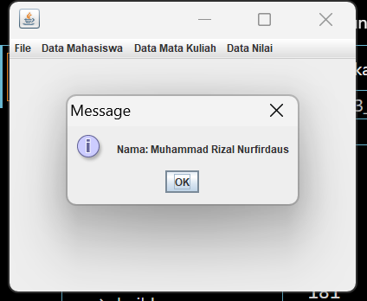

**Analisis :**

1. Menu "File" untuk membuka dan menyimpan file.

* Menu "Data Mahasiswa" untuk menampilkan nama dan NIM mahasiswa.
* Menu "Data Mata Kuliah" untuk menampilkan materi dan praktikum.
* Menu "Data Nilai" untuk menampilkan nilai UTS dan UAS.

1. **Listener**:

* Setiap item menu memiliki listener yang menjalankan aksi ketika menu diklik. Misalnya, membuka file dengan JFileChooser, menampilkan informasi dengan JOptionPane.

1. **Tampilan**:

* Aplikasi ini memanfaatkan **Nimbus Look and Feel** untuk tampilan GUI yang modern. Tampilan hanya menampilkan menu tanpa elemen grafis tambahan.